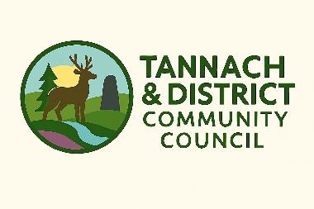



Micro-Grant Application Form

You may apply for up to £250 as an individual or £500 as a group.

- Contact Details:

Name of group or individual applying:

Main contact name (if a group):

Address:

Postcode:

E-mail: Telephone:

Please confirm if the event, group or you yourself are based in the Tannach and District Community Council area (see map on page 3): Yes / No

- About you / your group:

I am applying as (please tick one): An individual ☐
An un-constituted group ☐

- Details of Micro-Grant Requested:

Please provide details of your project – what activities will you carry out, who will benefit from these, and how?

How much are you requesting?

£

What will the micro-grant be used to pay for? (Please provide a breakdown of costs by item)

Are you applying to another fund? Yes / No (Please provide details and detail any match-funding you may have)

- Declaration:

I certify that, to the best of my knowledge, the information contained in this application is correct, and that I am authorised to make the application on behalf of the above group / individual.

Name (please print):

Signature: Date:

- Submitting your application:

Your application will be shared with local councillors, Foundation Scotland, and the Lybster and Tannach Fund.

Please send your completed application, clearly marked “MICRO-GRANT APPLICATION”, to:

tannachanddistrictcc@outlook.com

